Worksheet 2:  Our planet: now and in the future  www.dogstar.tv | 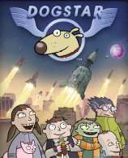

Student name:________________________________________________

Teacher:________________________________Class:_____________________

On one side of the circle draw images and symbols to show what our world is like now. On the other side of the circle draw images and symbols to show what you think it will be like in 20 years time.

The year today is: The year in 20 years will be:

