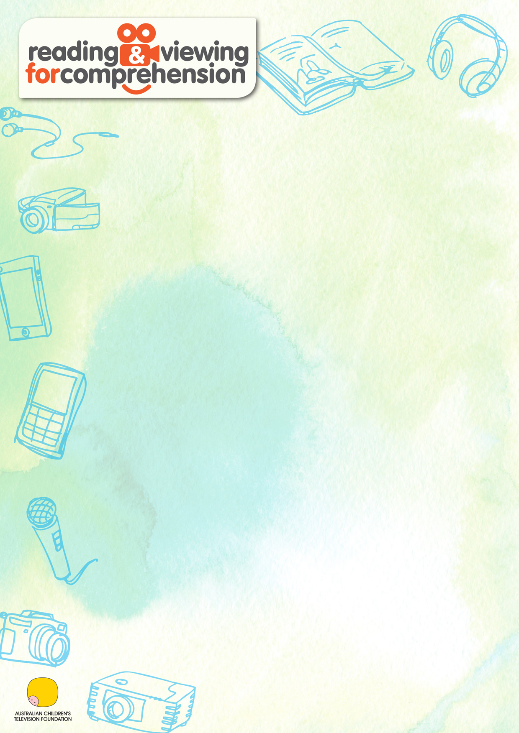

Round the Twist: Series 1, Episode 1, Skeleton on the Dunny

When the Twists move from the city to live in an old lighthouse, they discover that the outside dunny is haunted. One stormy night they decide to have a showdown with a very flushed ghost.

Clip: The ghost

When Linda wants to use the outside dunny (toilet), Bronson offers to accompany her. He fears that she will need to be protected from the ghost (old Ned). Linda objects because she doesn’t believe in ghosts… until she sees, and then she believes.

Curriculum links:

This is an extract from the Australian Curriculum V3.0: English

Year 5 Content Descriptions

ACELA1512 – Understand the use of vocabulary to express greater precision of meaning, and know that words can have different meanings in different contexts

ACELA1504 - Understand how texts vary in purpose, structure and topic as well as the degree of formality

ACELY1701 – Identify and explain characteristic text structures and language features used in imaginative, informative and persuasive texts to meet the purpose of the text

ACELY1698 – Show how ideas and points of view in texts are conveyed through the use of vocabulary, including idiomatic expressions, objective and subjective language, and that these can change according to context

ACELT1608 – Identify aspects of literary texts that convey details or information about particular social, cultural and historical contexts

ACELT1610 – Recognise that ideas in literary texts can be conveyed from different viewpoints, which can lead to different kinds of interpretations and responses

ACELT1795 - Use metalanguage to describe the effects of ideas, text structures and language features on particular audiences

© Australian Curriculum, Assessment and Reporting Authority 2012.

Useful resources:

Australian Children’s Television Foundation – The Learning Centre
Round the Twist online resources:
http://www.actf.com.au/teaching_resources?srch=&Yearlevel=&Curriculum_Study_Areas=&Themes=&show=11&Search=Search
The Australian Children’s Television website contains other specially selected Round the Twist clips, images and related resources that are available free of charge.

Round the Twist website
http://www.roundthetwist.com/home_noflash.htm
The Round the Twist website includes information about the cast, links to further episodes, teaching and learning suggestions and some interesting information about shooting the series.

Visual Literacy – K-8
http://k-8visual.info/
This site provides a definition of visual literacy and a host of examples. It also has some ideas about assessing students’ visual literacy capabilities.

Teaching Tips: Reading comprehension strategies
http://ethemes.missouri.edu/themes/1777
This website harvests and brings together reading comprehension strategies suitable for primary/middle years classes.

Analysis of moving image
http://www.englishbiz.co.uk/downloads/filmanalysis.pdf
Steve Campbell provides a very detailed two page glossary of terms for film analysis.

Teaching Dictogloss
http://www.carla.umn.edu/cobaltt/modules/strategies/Dictogloss.pdf
This url leads to a three page document explaining the dictogloss procedure. Dictoglosses were first developed for use as a language immersion strategy in foreign language education, but they also have their uses in mainstream education for introducing students to new vocabulary and language structures. This document has been prepared by Diane Tedick.

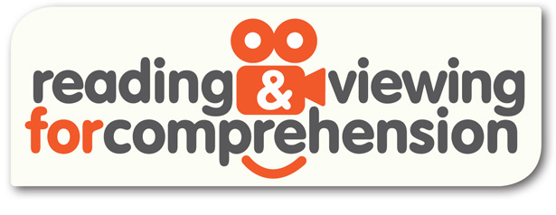

This is an extract from the Australian Curriculum V3.0: English

ACELY1701 – Identify and explain characteristic text structures and language features used in imaginative, informative and persuasive texts to meet the purpose of the text

© Australian Curriculum, Assessment and Reporting Authority 2012

Teaching activity A: Pre-viewing and viewing activity

Activating background knowledge – Scary stories:
Resources:
  - 10cm x 10cm pieces of coloured paper, cut into a speech bubble shape (one per student)
  - A5 size note-taking slip (two per student)
  - Bell
  - Camera
  - Display board

Think-pair-share:
- Individual thinking: Have students seated on the floor in one large circle. One student faces into the circle and the next student faces out of the circle. Keep alternating so half the students are facing in and half the students are facing out. The purpose is to give the students some separation for individual thinking. Ask a student to distribute the note-taking paper (one per student). Invite students to think of a time when they’ve seen a scary film, cartoon or music video clip. Tell students to write down the features/characteristics of a good scary film, scary cartoon or scary music video. After 3-4 minutes of individual thinking and writing, ring the bell to stop the activity.

- Pair’s discussion: Still seated in one large circle, ask students to turn so they are seated back to back with one other student whilst also facing one other student. This is the set up for a pair’s discussion. Have students discuss their ideas with the partner they are facing. After 6-8 minutes of pair’s discussion, ring the bell to halt the activity.

- Sharing with the class: Still seated in one large circle, all students face into the circle. Teacher asks individual students to contribute to the class discussion. Teacher scribes each student’s contributions onto a separate speech bubble slip. For example, ‘A good scary cartoon uses spooky music to build the tension.’ Only call for contributions from half of the students.

- Individual thinking: Ask students to return to their individual thinking position (large circle with half the students facing in and half the students facing out). Ask a student to distribute another sheet of note-taking paper (one per student). Invite students to think of a time when they’ve read a scary story. Ask students to write down the features/characteristics of a good scary story.

- After 3-4 minutes of individual thinking and writing, ring the bell to halt the activity.

- Pair’s discussion: Still seated in one large circle, have students turn so they are seated back to back with one other student whilst also facing one other student. This is the set up for a pair’s discussion. Pairs of students discuss the features of a good scary story. After 6-8 minutes of pair’s discussion, ring the bell to halt the activity.

- Sharing with the class: Still seated in one large circle, ask students to face into the circle. Elect individual students to contribute to the class discussion. Write down each student’s contributions onto separate speech bubble slips. This time, call for contributions from students who didn’t make contributions in the earlier part of the lesson. For example, ‘A good scary story has to have a lot of description about the monster so you can build a picture in your mind’. By the end of this part of the lesson, each student should have a scribed speech bubble slip about the features/characteristics of a good scary story (either moving image or written).

- Ask students to stand up, find a partner and find a space to stand together. Tell students to number off as ‘person 1’ and ‘person 2’. Person 1 becomes a lump of clay; they simply stand as a lump of clay until person 2 (the sculptor) sculpts them. Tell person 2 that they don’t physically touch their lump of clay; person 2 gives instructions to shape their lump of clay into the scariest statue possible. Once person 2 is satisfied with their efforts, they take a photo of their creation. Encourage students to explore different viewing positions to capture the desired effect.

- Repeat activity so person 2 becomes the lump of clay and person 1 is the sculptor and photographer.

- Display the photos and speech bubbles on a display board and have members of the class evaluate the photos and character positions.

This is an extract from the Australian Curriculum V3.0: English

ACELY1701 – Identify and explain characteristic text structures and language features used in imaginative, informative and persuasive texts to meet the purpose of the text

© Australian Curriculum, Assessment and Reporting Authority 2012

Teaching activity B: Exploring activity

Recall and sequence
Resources:
- Clip: The ghost (Round the Twist, Ep. 1 – Skeleton in the Dunny)
- ‘Talking ball’ (any special ball that can be passed around from student to student to indicate whose turn it is to talk)
- Student activity sheet 38.1: Still images (one copy of each page, printed on single side A3 paper, cut up into squares)
- Chalk or 5m of masking tape
- Long strip of card (3m x 15cm) for clip timeline
- 30 slips of note paper (10cm x 5cm) for student writing (one per student)

- As a class, view the clip, and initiate a discussion about the characters, the plot and the setting.

- Have students sit in one large circle. Hand the ‘talking ball’ to one student and ask them to tell the class how the clip started. This student then passes the talking ball to another student, who continues to recall the events of the clip. The purpose is to focus on content recall (literal viewing comprehension).

- With the class still seated in a large circle, mark out a 5m line on the floor (with chalk or masking tape). Scatter the still images from the clip (refer to Student activity sheet 38.1: Still images) in the centre of the circle. Each student selects one image and decides where it fits into the sequence. Have students line up along the marked line so their still shots are in sequence (from beginning to the end). This might take some negotiation amongst the students, especially with the many faces of Linda and the different shot sizes of the outdoor dunny. When the students think they have the order, replay the clip. If need be, have students stop the clip and rearrange themselves. It may take a few attempts. The purpose is to focus the students on the finer details of viewing images.

- Once the still shot sequence is sorted, each student takes it in turn to explain how their image fits into the plot. For example, ‘This is the image where Linda screams at Bronson to ‘nick off’.’ Ask students to write their explanation onto the slip of note paper.

- Ask students to glue their image onto the long sheet of card (middle row) and on the top row, glue their explanation slip. Give each row a title: PLOT and IMAGE.

This is an extract from the Australian Curriculum V3.0: English

ACELT1795 – Use metalanguage to describe the effects of ideas, text structures and language features on particular audiences

© Australian Curriculum, Assessment and Reporting Authority 2012

Teaching activity C: Responding activity

Reading the visual image:
Resources:
- Sequence timeline (from Teaching activity B)
- 30 slips of note paper (10cm x 5cm) for student writing (one per student)
- Glue

- Have students sit in one large circle and unroll the sequence timeline from Teaching activity B. Ask students to take turns in reminding the class what part of the plot their image represents.

- This activity focuses on the design of each frame from the sequence. Initiate a discussion with the students about the five media design elements and the choices a filmmaker makes when producing a filmed scene. Notate on the board student responses as a point of reference for the next part of the lesson:
  - Shot size (e.g. close up, medium, long distance)
  - Camera angle (e.g. bottom-up view as dominant; top-down view as weak)
  - Character position (e.g. facing each other or facing away)
  - Facial expressions (e.g. angry, happy, deep in thought)
  - Body gestures (e.g. pointing, using fist, relaxed)

- Discuss how the five media design elements of the filmmaker offers a system of evaluation about the relationships between characters. The five media design elements are also used to persuade the viewer to adopt particular responses and feelings toward the characters. The point is that five media design elements are not neutral.

- Distribute the slips of note paper (one per student) and ask students to deconstruct their image as per the five media design elements and write the details on their slip of paper. Students can refer to the notes on the board. For example, ‘This is a close up shot of the Dunny door. The camera angle is level which makes it seem like it’s someone else doing the viewing. We don’t see any characters, so we’re still wondering who’s doing the viewing.’

- Ask students to explain to the rest of the class what they have written and why they did so. The other members of the class should evaluate what each has chosen for their sequence frame. As they conclude their sharing, ask students to glue their notes under the sequence timeline. Give this row the title Media design elements.

This is an extract from the Australian Curriculum V3.0: English

ACELA1504 – Understand how texts vary in purpose, structure and topic as well as the degree of formality
ACELA1512 – Understand the use of vocabulary to express greater precision of meaning, and know that words can have different meanings in different contexts

© Australian Curriculum, Assessment and Reporting Authority 2012

Teaching activity D: Exploring activity

Dictogloss for building vocabulary and sentence structure:
Resources:
- Clip: The ghost (Round the Twist, Ep. 1 – Skeleton in the Dunny)
- Student activity sheet 38.2: Scary story (one copy for the teacher)
- One A4 blank sheet of writing paper per student (or one laptop per student)

- Write the words ‘MONSTER UNDER THE BED’ in the centre of the board/IWB and ask students to predict words or events that the title suggests to them. Write these predictions on the board as a semantic web. A semantic web is a web that is able to describe things in a meaningful way.

- Distribute Student activity sheet 38.2: Scary story, and read it together uninterrupted so students can build narrative comprehension skills. Have students jot down any words they’d like to discuss. At the end of the reading, ask students to offer up words for discussion. Writes these on the board so students can see their written form and discuss the meaning of each. Return to the predictions on the board. Identify the predictions that were confirmed by the reading of the story.

- Ask students to complete the first stage of a dictogloss after reading Student activity sheet 38.2: Scary story remind them to remember as much detail as possible. The purpose of a dictogloss is to focus the students on aspects of vocabulary and sentence structure that they might otherwise over look. After the reading, have students take a blank sheet of paper and write out as much of the story as they can remember. Ask the students to use the same words and sentence structure if they can. Allow students time to write down as many ideas as they can.

- Present another reading of the same story. This time, have students form into groups of two and together they try to reconstruct the story as best as they can. Repeat the sequence with a final oral reading and a shared reconstruction (with the same partner).

- When students have written as much as they can, bring all the students to a large circle on the floor. Ask pairs to volunteer to read their reconstructions. Compare vocabulary and sentence structure and consider ‘what has been left out’ and ‘what has been added’.

- Allow each pair of students to sit with the original story (Student activity sheet 38.2: Scary story) and their reconstruction, and edit for any missing elements.

This is an extract from the Australian Curriculum V3.0: English

ACELA1504 – Understand how texts vary in purpose, structure and topic as well as the degree of formality
ACELY1701 – Identify and explain characteristic text structures and language features used in imaginative, informative and persuasive texts to meet the purpose of the text

© Australian Curriculum, Assessment and Reporting Authority 2012

Teaching activity E: Applying activity

How structure varies across modes:
Resources:
- Clip: The ghost (Round the Twist, Ep. 1 – Skeleton in the Dunny)
- Student activity sheet 38.2: Scary story (one copy per student – from previous lesson)
- Student activity sheet 38.3: Modes of delivery (one A3 copy of each for group work)
- ‘Talking ball’ (any special ball that can be passed around from student to student to indicate whose turn it is to talk)

- As a class, view the clip, The ghost, and discuss the characters, plot and setting. Ask students to observe and list the different ways the filmmaker has developed the idea of a scary story. Particularly direct the students to elements of the setting, sound and script.

- Ask students to sit in large circle on the floor and ask students whether they prefer to view or read a scary story. They should also explain why they think so.

- Introduce student to Student activity sheet 38.3: Modes of delivery. The focus of this activity is on how structure varies across modes of delivery. Divide the class into groups of three and distribute one activity sheet per group. Have groups consider how their particular element is represented in moving image and written text. Students can refer to the clip, The ghost, and Student activity sheet 38.2: Scary story (the written story) for evidence. They should focus on how the element is presented in moving image and written image (if at all). Students should consider the following:
- Narrative structure – what stages does the text move through? (e.g. orientation, complication, resolution but often texts innovate)
- Point of view – whose view is presented?
- Setting – how do we find out about the setting?
- Mood – how are emotions and feelings communicated?
- Colour – how is colour use and to what effect?
- Gestures – what gestures are used and to what effect?
- Music and sound – what music and sounds are used and to what effect?

- Have the class share their findings. The focus here is on what is similar and what is different across the modes of delivery and what is the effect of what an author/filmmaker choses to use.

Reading a Media item
Ownership
Production/
intention
Technique
Genre/form
process
Subject
Images/sounds
Ideas/values
Audience
Literacy/
critical values
PROGRAM
CONTENT
FORM
SENDER
MEDIUM
MESSAGE
RECEIVER
How did they put it together? For example, Production roles.
Who constructed it and why?

Audience
Who are they?
How do they respond?

What is it about?

1. All media messages are constructions
2. Each person interprets messages differently
3. Media have commercial interests
4. Media has values
5. Each medium has its own language and style

Media uses recognised codes and conventions in order for the audience to identify with what is being portrayed. By the term 'code' we mean a communication system which contains media design elements which have an agreed meaning and which can be combined according to agreed rules.

There are four inter-related dimensions of media literacy:

- the cognitive - understanding how the message was produced and the symbols it uses
- emotional - understanding the cues that are used to trigger emotional responses in the audience
- aesthetic - understanding and appreciating the craft of the creators of the media
- moral - the ability to infer the values underlying the messages

The stages of media literacy range from recognising the most superficial meanings in what you experience (facial expressions, sound, colour), to taking social responsibility and making active choices and change in your life because of the impact such action can make (such as not watching or playing violent shows or games).

Each person’s level of media literacy depends upon many factors:
age, level of cognition, the social domain of the viewer, the culture of the viewer and media skills and knowledge. Like verbal and written literacy skills, media literacy cannot be studied in isolation from the meanings which readers produce.

There are three categories of codes that may be used to convey meanings in media messages:
    - technical codes, which include camera techniques, framing, depth of field, lighting and exposure and juxtaposition; the sound track including dialogue, natural location sound, music and sound effects. For example, bright, lively music signifies a comedy or upbeat scene in a drama or romance.

    - symbolic codes, are embedded in the text and create associations in the viewer’s mind for example, objects, setting, body language, clothing, colour, text and stereotypes. For example, the colour of a hat worn by characters in a western can instantly signal to us their status; white hat ‘goodie’, black hat ‘baddie’.

    - written/verbal codes in the form of headlines, captions, speech bubbles and language style.

Conventions enforce meaning in media. They can be defined as an accepted way of doing things. For example: fading in and fading out, media genres - software types, games, educational websites, etc. Audiences produce meaning from the interaction of the conventional material in the text, and their understanding of conventions:
- media conventions are historical - they come from somewhere and they are responsive to historical forces
- conventions are not natural but are cultural - they have cultural specificities - they are now somewhat universal, for example, advertising.

